Autumn 2 Newsletter 2025

The children have made a fantastic start to the school year, and we are so pleased with how well they have settled into school life. We are incredibly proud of the progress they are already making.

We are now looking forward to the exciting festive period ahead and hope you are too!
Our Topic for this half term
This half term, the children will be exploring a range of exciting topics, including Bonfire Night, Remembrance Day, a selection of traditional tales and Christmas.

If your child has a particular interest that you would like us to explore further in school, please speak to a member of the EYFS team. We are always happy to incorporate children’s interests into our planning to make learning as engaging and meaningful as possible.
We will be using the following books
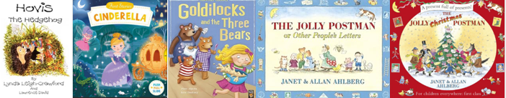

Upcoming Events
November
- Monday 3rd November – School Inset Day
- Monday 10th November – Odd Socks Day
- Friday 14th November – Cinderella’s Ball
- Week Commencing Monday 17th November – Parents/Guardians Evening
- Wednesday 19th November – Reception Height and Weight Checks
- Thursday 20th November – EYFS Maths Workshop for Parents/Guardians

December
- Thursday 4th December – EYFS Open Evening for Prospective Parents (2026 Intake)
- Tuesday 9th December – Christmas Pantomime (in school)
- Wednesday 10th & Friday 12th December – EYFS Nativity Performances
- Thursday 11th December – Christmas Jumper Day & EYFS Stay and Play
- Wednesday 17th December – EYFS Trip to Sale Waterside
- Thursday 18th December – Christmas Dinner Day

Reception- Reading books and sound books
Please remember to send your child’s reading book and sound book into school every day.

We encourage all parents and guardians to read with their child as often as possible.

Thank you for the fantastic support you are providing at home, it is wonderful to see the children’s confidence and progress in reading growing each week.
Phonics
In Nursery, the children will be introduced to phonemes- s, a, t, p, i, n and m. We are extremely excited to see our Nursery children begin to recognise different letter sounds.

In Reception, the children will continue to learn the remaining phase 2 sounds before being introduced to six new digraphs during this half term.
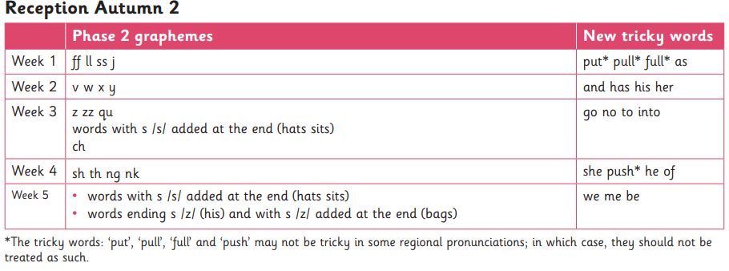

Reception- Phonic videos
Please scan the following QR codes to listen to the relevant videos aimed at supporting your child’s tricky word and sound knowledge.

Writing
In Nursery, the children will continue to develop their fine motor skills through engaging activities such as Dough Disco. We will keep encouraging them to give meaning to the marks they make, supporting the early stages of writing. When they are ready, the children will begin to trace the letters of their first name, helping to build their confidence and control.

In Reception, we will continue to focus on writing CVC (consonant–vowel–consonant) words. As the children progress, they will begin to write short captions to extend their skills. Reception children will also take part in daily handwriting sessions. Once your child can confidently write their first name independently, they will move on to writing their surname.
Letter formation
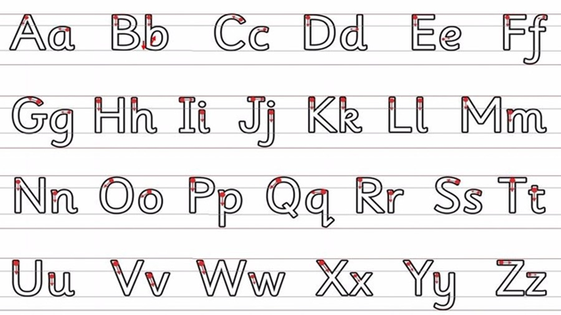

Maths
In Nursery, the children will be identifying the numeral 2, begin to develop 1-1 number correspondence, continue aba patterns and sort a variety of objects based on their size and colour.

In Reception, the children will be identifying and comparing circles, triangles, squares and rectangles. The reception children will be looking at the composition of the numbers 4 and 5. We will also be working hard to identify one more and one less than a given number.

PE
Each Friday the children will engage in a gymnastics session. This half term we will be focusing on bouncing, jumping and landing
Reminders
A few reminders:
• Please ensure your child’s name is in all items of uniform.
• Please ensure your child has appropriate clothes for the weather – we play out every day!

Thank you for your continued support. As always, if you have any concerns, please do not
hesitate to speak to us at the beginning or end of the day.

Mr Horan (EYFS teacher)



