

Attendance Policy
Cloverlea Primary
Version Change History
Version | Made by | Summary of Changes
v1.0 | Headteacher/K Spark | Adjustments made to be in line with Trust policy/recent KCSIE
V1.0 | Governors | Approved

Date published: September 2025
Date of next review: September 2026

- Introduction

“Improving attendance is everyone’s business.”

“… essential for pupils to get the most out of their school experience, including their attainment, wellbeing, and wider life chances. The pupils with the highest attainment at the end of Key Stage 2 and Key Stage 4 have higher rates of attendance over the key stage compared to those with the lowest attainment.”

(Working together to improve school attendance, DfE, 2022)

At Cloverlea, all staff work collaboratively to encourage every pupil to strive for excellence. Every child is supported, challenged and valued. One way in which we strive to do this is by encouraging staff, parents and children to maximise the learning experience in order that all children reach their full potential.

We are determined in encouraging the development of high self-esteem and for our children to take pride and ownership of their learning. In conjunction with this, we will continuously provide a clear framework for parents and staff as well as clear procedures for involving parents and/or external agencies where appropriate.

Our policy applies to all children registered at this school and this policy is made available to all parents/carers of pupils that are registered at our school on the school website.

Cloverlea encourages all parents/carers to work in partnership with the school to improve attendance and punctuality.

“The law entitles every child of compulsory school age to an efficient, full-time education suitable for their age, aptitude, and any special educational need they may have. It is the legal responsibility of every parent to make sure their child receives that education …”
(Working together to improve school attendance, DfE, 2022)

Our Home-School Agreement also emphasises the expectation that we have that children will attend school regularly and punctually.

This Attendance Policy follows DfE guidance “Working together to improve school attendance” (2022).

- Our Attendance Vision

Maximise the attendance rate of every child so that they are in school, supported and enabled to reach their full potential.

Our school mission and values underpin our attendance vision. Our mission statement ‘Inspiring children to care, learn and achieve’ encapsulates our purpose as a school and our four school values underpin this mission; principles upon which all members of the school community support us to embed in our school.

Achieving, Believing, Caring, Learning

Excellent attendance for every child is a critical factor in enabling us to achieve our mission and in enabling our children to achieve their potential. If attendance is outstanding, our children have improved life chances and will make more rapid progress academically and socially.

- Aims and Targets

The Governing body of Cloverlea Primary school strive to achieve standards and believe that excellent pupil attendance and punctuality are essential. For children to achieve their potential, pupils must be highly motivated to learn and keen and eager to attend school.

Regular, punctual attendance will establish good habits that will support them throughout their lives. To achieve this, the governors and staff are committed to working in partnership with parents to ensure that the school achieves a minimum of 97% attendance throughout the school.

Through this policy we aim to:
- Improve pupils’ achievement by ensure high levels of attendance and punctuality.
- Achieve a minimum of 95% for all pupils, apart from those with chronic health issues.
- Create an ethos in which high attendance and punctuality are recognised as the norm and seen to be valued by the school.
- Promote a positive and welcoming atmosphere in which pupils feel safe, secure and valued, and encourage in pupils a sense of their own responsibility.
- Raise awareness of parents, carers and pupils of the importance of uninterrupted attendance and punctuality at every stage of a child’s education.
- Promote good attendance habits, with non-compulsory school age pupils in Nursery and Reception.
- Work in partnership with pupils, parents, staff and external agencies so that all pupils realise their potential, unhindered by unnecessary absence.
- Establish a pattern of monitoring attendance and ensure consistency in recognising achievement and dealing with difficulties.

Recognise the key role of all staff in promoting good attendance.

Attendance during one school year … | equals this number of days absence … | which is approximately this many weeks absent … | which means this number of lessons missed. | Every Day Counts
100% | 0 days | 0 weeks | 0 lessons | EXCELLENT
97% | 5.5 days | 1 week | 20 lessons | GOOD
95% | 9 days | 2 weeks | 40 lessons | AVERAGE
93% | 13 days | 3 weeks | 60 lessons | POOR
90% | 19 days | 4 weeks | 80 lessons | PERSISTENT ABSENTEE –  VERY POOR
85% | 29 days | 6 weeks | 120 lessons | PERSISTENT ABSENTEE –  VERY POOR
80% | 38 days | 8 weeks | 160 lessons | PERSISTENT ABSENTEE –  VERY POOR

- Roles and Responsibilities

4a. Parents
- Ensure that their children attend school regularly
- Notify school on the first day of absence before 9.30am by phone/letter/email
- Complete a request form for absence in term time for exceptional circumstances
- Hand in medical evidence where attendance rate and/or attendance pattern is a concern for the school (typically below 93%).
- Meet with the Headteacher/ Deputy Head to discuss their child’s attendance when necessary

4b. Class Teachers
- Complete register at the start of each session (morning and afternoon)
- Monitor daily patterns of attendance and report any concerns that arise to the SLT
- Provide work for children to do at home if an absence is due to a long illness, disability, or other exceptional circumstances
- Make parents aware of concerns over good attendance

4c. Office Staff
Mrs Moss is responsible for Attendance Adminstrator within the school office.
- Input attendance data on Arbor system
- For children for whom absence is a concern, input any absence, and communication from parents, on CPOMs
- Print a weekly attendance update, with attendance rate for every child
- Print off official reports for each calendar month for monitoring purposes (or more frequently if required) and update on Attendance Spreadsheet.
- Monitor alongside the Headteacher and Attendance Lead, patterns of attendance and lateness and immediately raise any concerns.
- Make first day absence calls and record reasons for absence
- Follow up on unexplained absences
- Carry out attendance procedures with parents of children whose attendance is of a concern

4d. Attendance Lead
Mr McConnell is our Attendance Lead.
They can be contacted through the school email (cloverleaprim.admin@trafford.gov.uk) by phone 0161 980 8338

Punctuality
- Daily meet and greet at front of school all children.
- Liaise with parents regarding any issue which also helps to build positive relationships.
- Contact home and speak where possible to all parents to discuss reasons why the child is arriving late to school, again to foster positive working relationships.
- In the case of persistent lateness invite parent/carers to attend school to discuss and formulate a plan.

Attendance
- Liaise with parents regarding any issue which also helps to build positive relationships.
- Closely monitor attendance of PA children and act swiftly if they are absent.
- Liaise closely with school office each morning to determine children who are absent and to find out why.
- Ensure that all interventions / conversations / actions are logged on CPOMs.
- Carry out home visits to check on the welfare of a child if required.
- Liaise closely with and share information with other agencies if appropriate.
- Highlight persistent absence concerns with SLT as soon as possible.
- Work with Headteacher to meet with parents and put Attendance Plans (Parenting Contract) in place for children whose attendance rate is a concern.

Attendance Data
- Work with SLT to analyse attendance data (whole school, cohort, class, pupil groups, individual pupils) to identify patterns and areas of concern and to plan action to address.

4e. Headteacher
Mr McConnell, Headteacher, is the Strategic Attendance Lead for our school and overseas all the work to promote and support good attendance.

They can be contacted through the school email (cloverleaprim.admin@trafford.gov.uk) by phone 0161 980 8338

- Work closely with school office and Attendance Lead to closely monitor all absences.
- Analyse weekly and monthly attendance data, monitor official registers and take actions where concerns have been identified.
- Report to governors termly on attendance performance.
- Inform parents of individual pupils’ attendance record, each term at Parents’ Evening and in the end of year schools report.
- Inform/Meet with parents whose children’s attendance causes concern.
- Work with Attendance Lead to meet with parents and put Attendance Plans (Parenting Contract) in place for children whose attendance rate is a concern.
- Make referrals to the School Nurse / Early Help / First Response

4f. Governing body
- Monitor whole school attendance termly and take appropriate action should it affect standards.
- Nominate a named Governor for Attendance (Safeguarding Governor) and meet at least twice yearly to discuss attendance.
- Approve the Attendance Policy
- Monitor attendance patterns across the school and monitor/evaluate the impact of the Attendance Policy

- Punctuality
When a child arrives on time:
- Registration takes place quickly and smoothly
- An activity is put on the board or out around the classroom
- The day gets off to a good start for everyone
- Everyone hears the information given and is included in important explanations and discussions. This ensures that everyone knows what to do and what is expected of them

When a child arrives late:
- It interrupts concentration
- It wastes valuable learning time
- The teacher repeats information / instructions whilst others have to wait
- The late child is at an immediate disadvantage because they may have missed important teaching points, missed discussions where ideas are shared and will be generally unsettled

It is the parent/carers responsibility:
- To ensure that their children arrive to school on time. Our doors open at 8:45am providing a 15 minute window for the children to arrive. This is sufficient time for all pupils to get to their classroom. School officially starts at 9am and the doors are closed at that time. Registers are taken at 9am and are officially closed at 9.30am. From 9am, any children arriving MUST report to the main entrance and they will receive a late mark.
- To ensure children are collected promptly at the end of the school day and that necessary arrangements are in place for the journey home. If these differ from the child’s normal arrangements, the class teacher and school office should be made aware of this.
- Children who arrive late (after the doors close) and have gone to the office entrance, must be signed in by their parent/carer or appropriate adult, a reason for the lateness is also requested. The admin staff will update the Arbor system with their mark. Adults of EYFS children will wait with their child until it is convenient for the child to be taken to class.
- Children who have to leave for any reason throughout the day must be signed out at the main office by their parent/carer or appropriate adult. However, this is strongly discouraged. Parents are requested to make dental or medical appointments outside of school hours.

- Holiday in Term Time Procedures

Any absence, other than for genuine illness or emergency medical attention, will most likely be classed as unauthorised unless exceptional circumstances. As a school we do not authorise days absence for holidays – holidays are not exceptional circumstances.

Where an unauthorised holiday is taken in term time, a request will be made to the LA to issue a fine, in line with Trafford’s Penalty Notice procedures.

Parents may choose to complete an ‘Exceptional Circumstances Form’ stating why they are requesting to remove their child during term time. This is given to the Headteacher. Only exceptional circumstances will this be authorised. The decision whether to authorise an ‘exceptional circumstance’ will be made by the Headteacher.

- Religious observance
In line with local authority guidance, the school will authorise up to two days absence due to religious observance in an academic year.

- Strategies for Monitoring Good Attendance

- Individual praise postcards sent home half termly where ‘target’ attendance (97%) has been gained (this is always calculated cumulatively from September).
- Praise postcards / letter sent home where a child’s attendance rate shows significant improvement.
- Headteacher will monitor attendance and any child with below 95% attendance will trigger concern resulting attendance procedures to take place (see flow chart) and/or an action plan to be put in place.
- Monthly attendance update on Headteacher’s newsletter for parents.

- Addressing Poor Attendance

“Where absence escalates and pupils miss 10% or more of school, schools and local authorities are expected to work together to put additional targeted support in place to remove any barriers to attendance and reengage these pupils.”
Working together to improve school attendance, DfE 2022

See Appendix A and D

- School attendance, Safeguarding and Children Missing Education

A child going missing from education is a potential indicator of abuse or neglect. School staff will follow the Trust’s procedures for dealing with children that go missing from education, particularly on repeat occasions, to help identify the risk of abuse and neglect, including sexual exploitation, and to help prevent the risks of their going missing in future Keeping Children Safe in Education (2025) and Children Missing Education 2024).

All Schools are required to make the local authority aware of every registered pupil who fails to attend school regularly and any children who have been absent from school, where the absence has been treated as unauthorised for a continuous period of not less than 10 school days Education (Pupil Registration) (England) Regulations 2006 regulation 12.

This attendance policy is part of broader suite of Safeguarding policies including the school’s Safeguarding and Child Protection Policy.

- Illness

It is a school’s decision whether to accept a reason for a child’s absence and whether to authorise that absence. In the majority of cases a parents’ note/email/phone call explaining that their child was ill can be accepted without question or concern. Where attendance rate and/or attendance pattern is a concern for the school (typically below 93%) further evidence of a child’s illness may be requested for the absence to be authorised.

This policy reflects the mission and aims of Cloverlea Primary School.

- Pupils with medical conditions or special educational needs and disabilities

We understand that some pupils face greater barriers to attendance than their peers. These can include pupils who suffer from long term medical conditions or who have special educational needs or disabilities. Whilst we are equally ambitious in our attendance expectations for all children, we recognise that we should be mindful of barriers that some children will face and commit to working closely with parents and putting in place additional support where necessary to enable them to access full-time education.

Appendices
Appendix A: Flow chart of late procedures
Appendix B&C: EXAMPLE Late Letters: Letter 1 (Late warning letter), Letter 2 – (Invitation to a School Review Lates Meeting)
Appendix D: Flow chart of attendance procedures
Appendix E: EXAMPLE Attendance Letters: Letter 1 (Whole School Attendance Letter), Letter 2 (Headteacher concerns letter), Letter 3 (Medical evidence/request letter), Letter 4 (Invitation to a School Review Attendance Meeting)
Appendix F: Term Time Leave Request Form
Appendix G: Attendance Contract Template

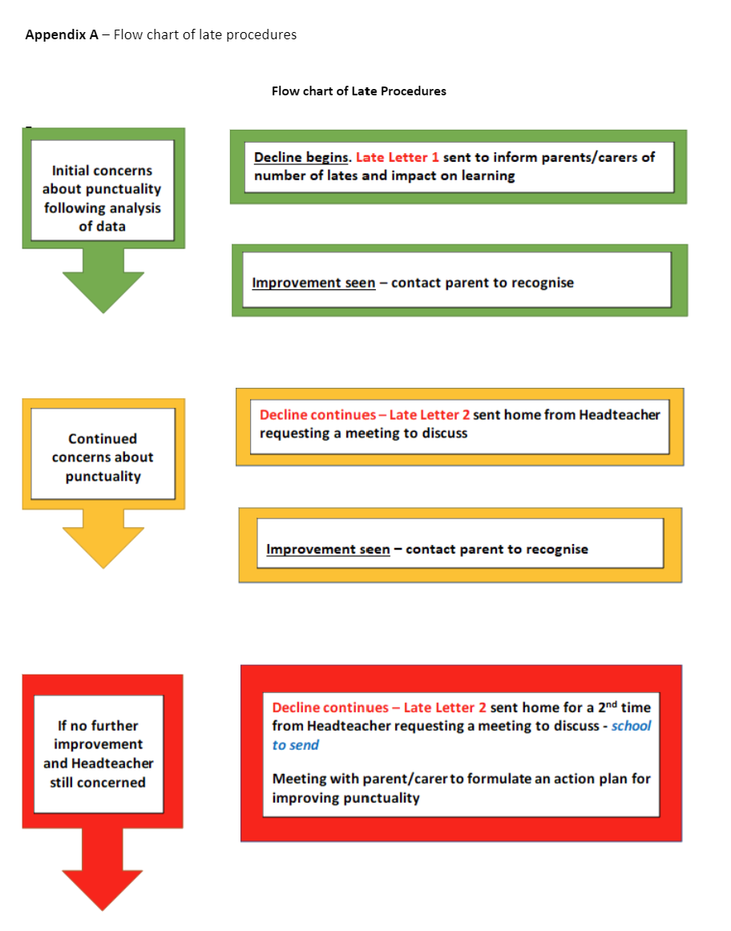

Appendix B – Late Letters: EXAMPLE Letter 1 (Late warning letter)
Insert date
«ParentTitle» «ParentFirstName» «ParentLastName»
«AddressLine1» «AddressLine2»
«City»
«PostCode»
Dear «ParentTitle» «ParentLastName»
Your child, «ChildFirstName» «ChildLastName» has been identified as having poor punctuality.
We are sure you are aware that XXXX can enter school from 08.45 to enable him to be in class for registration at 9am.
Please note that children arriving after 9am will be recorded as an unauthorised late for the morning session, this will affect your child’s attendance record. May we also remind you that if children arrive late a parent/carer should accompany them to the school office to sign them in.
As you may be aware, the law treats some persistent lateness in the same way as irregular attendance and parents may be prosecuted by the Local Authority if late arrival is not resolved.
I have to advise you as a parent/carer of a child of statutory school age, you have a legal responsibility to ensure full time education suitable to the child’s age, ability and aptitude and any special educational needs the child may have, either by regular attendance at school or otherwise. (Education Act 1996)
Minutes late per day during the school year | Equals days’ worth of teaching lost in a year
5 mins | 3.4 days
10 mins | 6.9 days
15 mins | 10.3 days
20 mins | 13.8 days
30 mins | 20.7 days

Poor punctuality can lead to your child …
- Feeling embarrassed in front of their friends
- Missing the beginning of vital lessons
- Missing important instructions for the rest of the school day
- Learning bad habits which could affect their employability in the future
If your child is having any difficulties that you wish to discuss, contact me immediately. Your child’s punctuality must now improve or the school may have no option but to take further action against you.
Yours sincerely,

Appendix C – Late Letter: EXAMPLE Letter 2 – (Invitation to a School Review Lates Meeting)
Insert date
«ParentTitle» «ParentFirstName» «ParentLastName»
«AddressLine1» «AddressLine2»
«City»
«PostCode»
Dear «ParentTitle» «ParentLastName»
Your child, «ChildFirstName» «ChildLastName» has been identified as having poor punctuality. This year he/she has been late on ?? occasions.
As you may be aware, the law treats some persistent lateness in the same way as irregular attendance and parents may be prosecuted by the Local Authority if late arrival is not resolved.
I have to advise you as a parent/carer of a child of statutory school age, you have a legal responsibility to ensure full time education suitable to the child’s age, ability and aptitude and any special educational needs the child may have, either by regular attendance at school or otherwise. (Education Act 1996)
Minutes late per day during the school year | Equals days worth of teaching lost in a year
5 mins | 3.4 days
10 mins | 6.9 days
15 mins | 10.3 days
20 mins | 13.8 days
30 mins | 20.7 days

I previously wrote to you in ??? to advise you of my concern with XXXX punctuality. As there has been no improvement, I now wish to request a meeting with you to discuss the situation and to see how we can support you in improving XXX punctuality. Please can I ask you to contact the school office to arrange this meeting.
Yours sincerely,

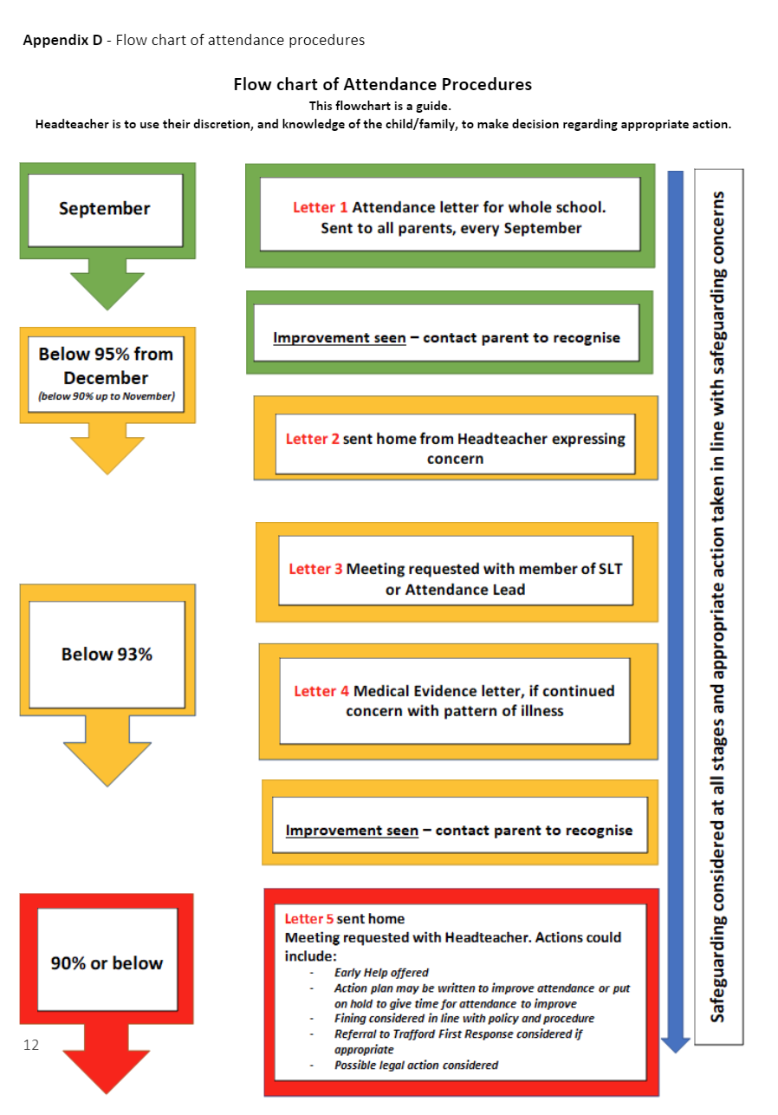
Appendix E – Attendance Letters: EXAMPLE Letter 1 (Whole School Attendance Letter)

Attendance - A very important message for all Parents/Carers
Insert Date
Dear Parent/Carer,
At the start of the new school year we would like to remind all parents of the importance of attendance and punctuality. We recognise that many parents ensure their child attends school regularly and is punctual and we thank you for your strong support.
At Cloverlea, we recognise that good attendance and punctuality are central to raising standards and pupil attainment. For our children to gain the greatest benefit from their education it is vital that they attend regularly and be at school, on time, every day the school is open unless the reason for the absence is genuinely unavoidable.
TIME OFF SCHOOL AFFECTS YOUR CHILD’S ACHIEVEMENT
Attendance during one school year … | equals this number of days absence … | which is approximately this many weeks absent … | which means this number of lessons missed. | Every Day Counts
100% | 0 days | 0 weeks | 0 lessons | EXCELLENT
97% | 5.5 days | 1 week | 20 lessons | GOOD
95% | 9 days | 2 weeks | 40 lessons | AVERAGE
93% | 3 days | 3 weeks | 60 lessons | POOR
90% | 19 days | 4 weeks | 80 lessons | PERSISTENT ABSENTEE –  VERY POOR
85% | 29 days | 6 weeks | 120 lessons | PERSISTENT ABSENTEE –  VERY POOR
80% | 38 days | 8 weeks | 160 lessons | PERSISTENT ABSENTEE –  VERY POOR

If your child’s attendance rate is below 95%, their absence rate will be affecting their learning and achievement and we will be in contact with you. Please work with us to ensure your child has the very best opportunity to achieve their very best.
Questions to ask yourselves:
Does my child really need to be absent from school?
Unless a child has a long-term health condition incidents of absence due to illness should be rare. Whilst we don’t wish a child to be sent to school if they are genuinely ill, we do encourage children to attend school when they are suffering from minor ailments such as a cold as this will establish good habits that will support them throughout their lives.
We appreciate that it is difficult to assess whether you should send your child into school if they feel poorly, rest assured we will contact you to collect them if they are too ill to be in school.
Is it appropriate to take my child out of school for a holiday?
The Trust Board and Governing Body have determined through our Attendance Policy that we will not authorise holidays. Holidays will all be regarded as unauthorised and subject to Fixed Penalty Notice. Please note we will automatically request medical evidence for any illness absence taken immediately before or after a school holiday.
Does my child have to attend a medical appointment during the school day?
We ask that you endeavour to attend medical appointments out of school hours
Please can I once again emphasise how much we appreciate your on-going support.

Appendix E – Attendance Letters: EXAMPLE Letter 2 (Headteacher concerns letter)
Insert date
«ParentTitle» «ParentFirstName» «ParentLastName»
«AddressLine1» «AddressLine2»
«PostCode»
Dear «ParentTitle» «ParentLastName»
Re: «ChildFirstName» «ChildLastName» - D.O.B. «ChildDOB» Yr «YearGroup»
I’m writing to you to express concern about «ChildFirstName» attendance in school. Please see the attached Attendance Certificate for further details.
As you may be aware, it is the legal responsibility of parents to ensure children attend school regularly.
TIME OFF SCHOOL AFFECTS YOUR CHILD’S ACHIEVEMENT

Attendance during one school year … | equals this number of days absence … | which is approximately this many weeks absent … | which means this number of lessons missed. | Every Day Counts
100% | 0 days | 0 weeks | 0 lessons | EXCELLENT
97% | 5.5 days | 1 week | 20 lessons | GOOD
95% | 9 days | 2 weeks | 40 lessons | AVERAGE
93% | 3 days | 3 weeks | 60 lessons | POOR
90% | 19 days | 4 weeks | 80 lessons | PERSISTENT ABSENTEE –  VERY POOR
85% | 29 days | 6 weeks | 120 lessons | PERSISTENT ABSENTEE –  VERY POOR
80% | 38 days | 8 weeks | 160 lessons | PERSISTENT ABSENTEE –  VERY POOR
We work with parents to improve school attendance. Good attendance will mean that your child is able to achieve the best grades for their ability and have real opportunity in further education and the world of work. Absence disrupts the education of the individual pupil and the whole class. Children who do not attend regularly:
- do not achieve their potential as absence affects their learning and achievement
- find it difficult to maintain friendships
- miss out on social events
If you feel that your child has ongoing or unresolved medical issues you are advised to approach your doctor urgently.
If you wish to discuss the contents of this letter or your child’s attendance please contact the school. If you call and there is no one available, please leave a message and contact telephone number.
I look forward to seeing «ChildFirstName» attendance improve over the coming weeks and thank you in advance for your support.
Yours sincerely,

Appendix E – EXAMPLE Letter 3 (Medical evidence/request letter)
Insert date
«ParentTitle» «ParentFirstName» «ParentLastName»
«AddressLine1» «AddressLine2»
«City»
«PostCode»
Dear «ParentTitle» «ParentLastName»
Re: «ChildFirstName» «ChildLastName» - D.O.B. «ChildDOB» Yr «YearGroup»
Your child’s poor attendance at school this year is causing serious concern as he/she has been absent for number of sessions out of a possible number of sessions and this will make it much harder for your child to achieve good results in their school work. Most/ All of the absence has been due to illness or for medical reasons.
I have decided that due to the high level of your child’s absence, I will no longer authorise any absence for medical reasons unless supported by medical evidence.
I have to advise you that we monitor all pupils with poor school attendance and will take action when absence is unauthorised; this may lead to prosecution.
Therefore should Pupil’s name have any further sessions of absence because of illness or medical reasons you are strongly advised to provide one of the following which may enable the me to authorise your child’s absence:
- Medical appointment card with one appointment entered
- Letter from a professional such as a hospital Consultant or Psychologist
- Evidence of a consultation with NHS 111
- Medication prescribed by a GP
- Copy of prescription
- Print screen of medical notes
- Letters concerning hospital appointments
- Slip with date, pupils name and surgery stamp, signed by Receptionist
Doctors or GP ‘sick’ notes are not required. Please do not request these from your GP.
Please be aware that telephone calls and handwritten notes from a parent/carer are not acceptable as medical evidence when attendance is of serious concern. I have to advise you as a parent/carer of a child of statutory school age, you have a legal responsibility to ensure full time education suitable to the child’s age, ability and aptitude and any special educational needs the child may have, either by regular attendance at school or otherwise (Education Act 1996 Section 444).
We work with parents to improve school attendance. Good attendance will mean that your child is able to achieve the best grades for their ability and have real opportunity in further education and the world of work. Absence disrupts the education of the individual pupil and the whole class.
Children who do not attend regularly:
- do not achieve their potential
- find it difficult to maintain friendships
- miss out on social events
If you feel that your child has ongoing or unresolved medical issues you are advised to approach your doctor urgently. If you wish to discuss the contents of this letter or your child’s attendance, please contact school.
Yours sincerely,

Appendix E – Attendance Letters: EXAMPLE Letter 4 (Invitation to a School Review Attendance Meeting)

Insert date
«ParentTitle» «ParentFirstName» «ParentLastName»
«AddressLine1» «AddressLine2»
«City»
«PostCode»
Attendance Invitation to a School Attendance Review Meeting
Dear «ParentTitle» «ParentLastName»
Re: «ChildFirstName» «ChildLastName» - D.O.B. «ChildDOB» Yr «YearGroup» at «SchoolName»
There have been continuing difficulties concerning the attendance of your child «ChildFirstName» «ChildLastName» at «SchoolName».
You have been offered advice and support to improve «ChildFirstName»’s attendance.
In an attempt to resolve issues regarding attendance, I request an urgent School Attendance Review Meeting.
It is very important that you contact me to arrange a convenient time and date. Your co-operation is essential.
This meeting is an opportunity for you to discuss any matters of concern. Failure to attend this meeting and further unauthorised absence could result in you being prosecuted in court and/or a penalty notice being issued.
I have to advise you as a parent/carer of a child of statutory school age, you have a legal responsibility to ensure full time education suitable to the child’s age, ability and aptitude and any special educational needs the child may have, either by regular attendance at school or otherwise (Section 444, Education Act 1996).
Please contact me urgently to arrange a meeting within the coming week.
Yours sincerely

Appendix F – Exceptional Circumstances Form

EXCEPTIONAL CIRCUMSTANCES REQUEST
EVERY SCHOOL DAY COUNTS
Dear Parent/Carer,
The law states that you do not have the right to take your child out of school during term time. The local authority works with the school to reduce the number of children missing school because of absence taken in term time and the school may not approve your request to take your child out of school.
The regulations allow Head Teachers discretion to grant permission for authorised leave of absence in exceptional circumstances. It is important to ensure that should you need to request leave of absence for your child you should give as much notice as possible and certainly not less than 28 days.
There are times of the year when a child may experience extra problems because of missing school. These include test periods, at the time of starting a new school or at the start of a new school term. In deciding whether to authorise your child’s absence and give permission for a leave of absence in term time, the school will take these and other factors into account.
If your application is refused and you still take your child out of school, the absences will be treated as unauthorised. Unauthorised absences will lead to a Penalty Notice or a Summons being issued against you for irregular school attendance.
Having read the information if you still wish to apply for leave of absence for your child in exceptional circumstances then please complete the application form attached. You should be aware that leave of absence will not be granted for a holiday during school time.
Your application form should be returned to the school office as far in advance of the proposed absence as possible and no later than 28 days before the absence is proposed.
Yours faithfully,

Mr McConnell
Headteacher

EXCEPTIONAL CIRCUMSTANCES REQUEST FORM
Parents do not have a right to take their children out of school for leave during term time. Parents wishing to apply for their child to have leave from school should complete this form and return it to school, giving at least 4 weeks’ notice, waiting for authorisation.
Regular attendance is an important factor in your child’s performance at school. Please think carefully before deciding to request leave of absence.
PARENTS SECTION (Please Complete All Boxes)
Name of child/children:

Class(es):

First date of absence: dd/mm/yyyy
Date of Return: dd/mm/yyyy
Number of days requested:

Reason for Request:

Would s(he) miss any national/school tests? (in May)
No holidays will be authorised in May (for all year groups) unless assessment period is over.
Would s(he) miss any preparation for national tests?
No holidays will be authorised in March or April for Year 2 or 6.
Have you requested time off in term time before?

I understand that if leave of absence is not agreed it will be treated as unauthorised and may lead to the issue of a penalty notice for £60, which increases to £120 if not paid within 14 days. I am also aware that non-payment of a penalty notice may result in a summons for irregular school attendance.

Name of parent/carer making application:
Signed: Date:
For Office Use Only
Attendance last academic year: | Comments:
Attendance this academic year: | Comments:
Approved Not Approved
Signed (Headteacher):

Appendix G – Attendance Contract Template

Attendance Contract Template

Date/time of meeting:
Venue:

Pupil name:
Date of birth:
Address:
School:

Present at meeting:

Action agreed
EXAMPLES OF ACTION AGREED:
Pupil will arrive at school by 9.00a.m. every day.
Parent will inform the school on the first day of a sickness absence and provide a note upon pupil’s return.
Parent will provide medical evidence for every sickness absence pupil may incur.
Are any issues preventing pupil from attending regularly, school staff will be informed?

Attendance target: | 100%
Timescale for improvement:

Date for review meeting:

I confirm that this Attendance Action Plan was agreed by all present.

Signed:

…………………………………………… Parent/carer

…………………………………………… Pupil

…………………………………………… School Representative

…………………………………………… Other Agency

