Hooks/ experiences mapped out- 2026/27- Some experiences TBC
Autumn 1  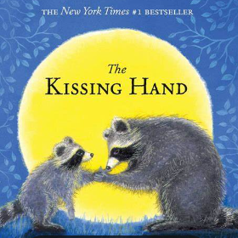WC 7th September- Transition days  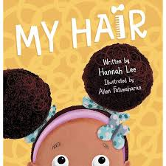 WC- 14th September- Hairdressers role play  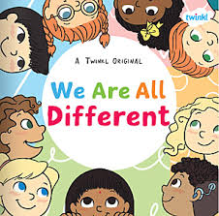 WC 21st September:  - Self-portrait painting  - Reading Workshop- 24th September  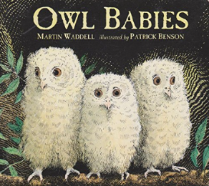 WC 28th September -Autumn walk  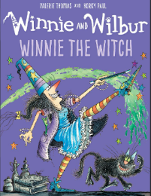 WC 5th October- Maths workshop 8th October  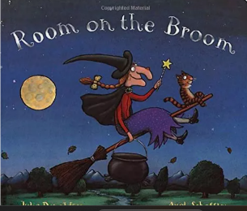 WC 12th October- Dentist visit  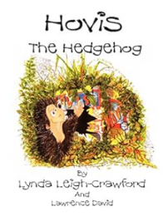 WC 19TH October- Fire brigade visit before Bonfire Night. | Autumn 2  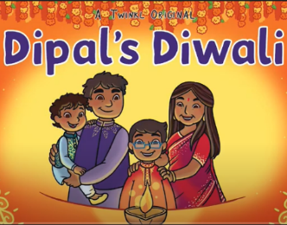 WC 2nd November:  - Make Diyas- Diwali-6th November  - Remembrance Day Activities- 8th November  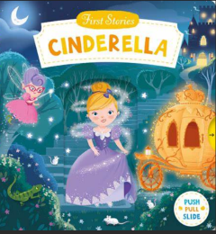 WC 9th November- Cinderella’s ball  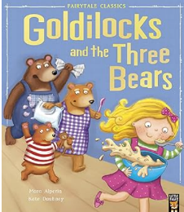 WC 16th November- Porridge making  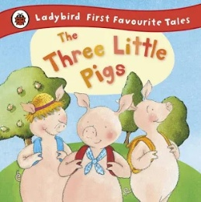WC 23rd November- Large scale construction using different materials  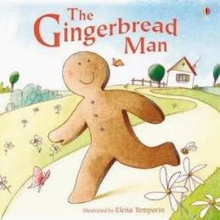WC 30th November- Stay and play session- 3rd December  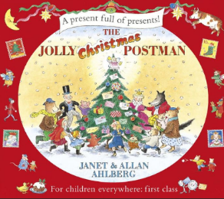 WC 7TH and 14th December:  - A visit from Father Christmas  - Make Christmas cards and crafts  - Christmas Nativity
Spring 1   WC 4th January/ 11th January-New Nursery starters  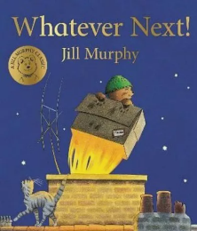 WC 18th January- Rocket and space launch  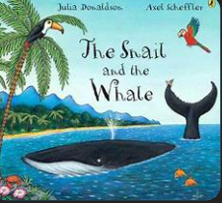 WC 25th January:  - Map work  - Save the Whale hunt- early orienteering  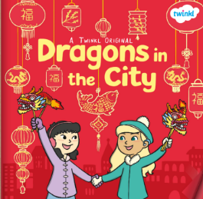 WC 1st and 8th February:  - Try Chinese food  - Create Luna New Year and Valentine’s Day crafts | Spring 2   WC 22rd February- Make vegetable soup  WC 1st March- World Book week- 4th March and Mystery Readers  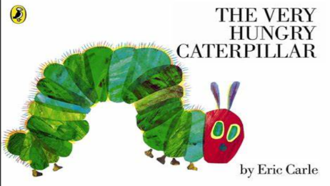 WC 8th and 15th March:  - Order butterfly kits of next half term  - Mother’s Day craft- 7th March  - Eid Activities this week- 9th March  - Stay and Play session- 18th March  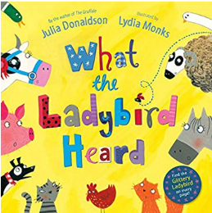WC 22nd March:  - Easter and spring activities  - Police Visit
Summer 1  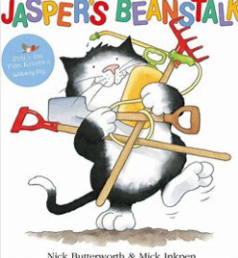 WC 12th April- Plant sunflowers/ Butterflies to arrive  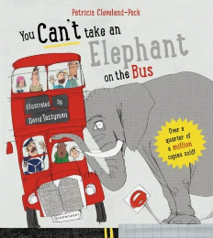 WC 19th April:  - Road safety  - St George’s Day 23rd April  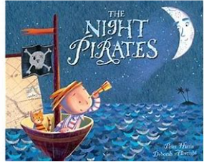  WC 26th April-Floating and sinking- home project- Children to bring in their own boats from home will they float in a large paddling pool outside?  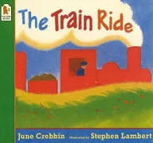 WC 3rd May:  - Conduct a traffic survey  - Explore old modes of transport  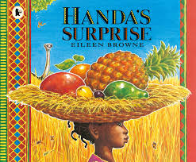 WC 10th May- Fruit tasting  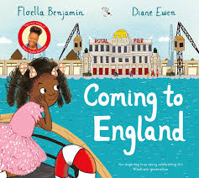 WC 17th and 24th May- Z- Arts trip? | Summer 2  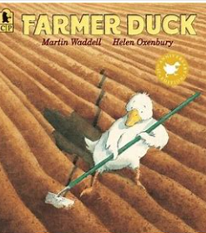WC 14th and 21st June:  - Reception to walk down the path by themselves  - Reception to begin to attend assemblies  - Welcome meeting for new children  - Make Father’s Day cards   WC 28th June- Sponsored bounce/ bike ride  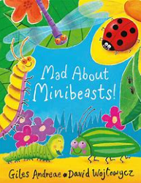 WC 5th July:  - Sports week-5th July  - Minibeast hunt  - Transition day?  - Stay and play- 8th July  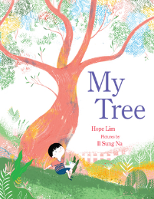  WC 12th and 19th- Transition into YR1/YR- reflect on the school year

