Autumn 1 Newsletter – September 2026

We hope that you have had a wonderful summer. Over the next few weeks, we are looking forward to getting to know your precious little one. Throughout September, our focus is on helping children to know the rules and routines of the classroom and the wider school.

The EYFS Curriculum
We follow the Early Years Foundation Stage Curriculum, which has seven areas of learning.

These areas are:
- Communication and language.
- Personal, social and emotional development.
- Physical development.
- Literacy.
- Mathematics.
- Understanding the world.
- Expressive arts and design.

Every week, we ensure the children experience all the areas of learning. Both our indoor and outdoor environments are set up to allow the children to practice and consolidate what they learn. We adapt our planning based on the children’s next steps.

Our Topic for this half term
This half term, we are covering the topic ‘Amazing Me.’ During this topic, we will be exploring the following questions:

- Who are the people in my family?
- What makes me different?
- What do we call the different parts of our body?
- What do I need to grow healthy and strong?
- How do I use my senses?

If your child has a particular interest that you would like them to explore further at school, please let Mr Horan or Mrs Blackburn know, and we will include that in our planning.

We will be using the following books

We will be covering the following vocabulary
In Nursery and Reception
- Mum, Dad, baby, family, Grandad, parents, sister, brother, cousins, Granny/Nan, Uncle, Aunt
- Son, daughter, niece, nephew, grandchild, celebration
In Reception
- Relatives, relationship

Phonics
In Nursery and Reception, we follow the Little Wandle phonics scheme. Your child will engage in daily phonics sessions.

Nursery- During Autumn 1, the Nursery children will be exploring rhyme.

Reception- The children will begin Reception by consolidating their segmenting and blending skills and learning Phase 2 phonemes. The YouTube video titled ‘Phase 2 sounds taught in Reception Autumn 1’ demonstrates the correct pronunciation of each sound.

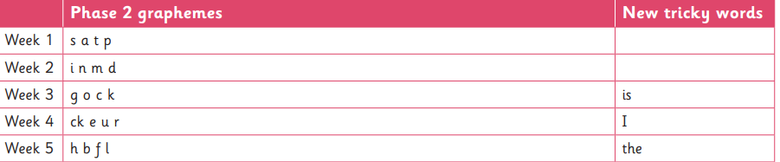

Writing
Nursery- This half term, the children will develop their fine motor skills through activities such as Squiggle Whilst You Wiggle and Dough Disco. We will also encourage the children to make different marks within ‘The Message Centre’ area of the classroom.

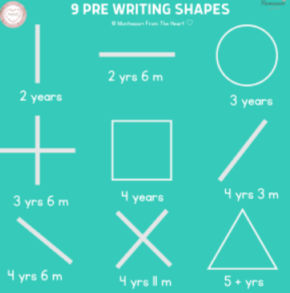

Reception-This half term, the children will be practising forming their name and writing initial and final letter sounds. We initially focus on forming lower-case letters.

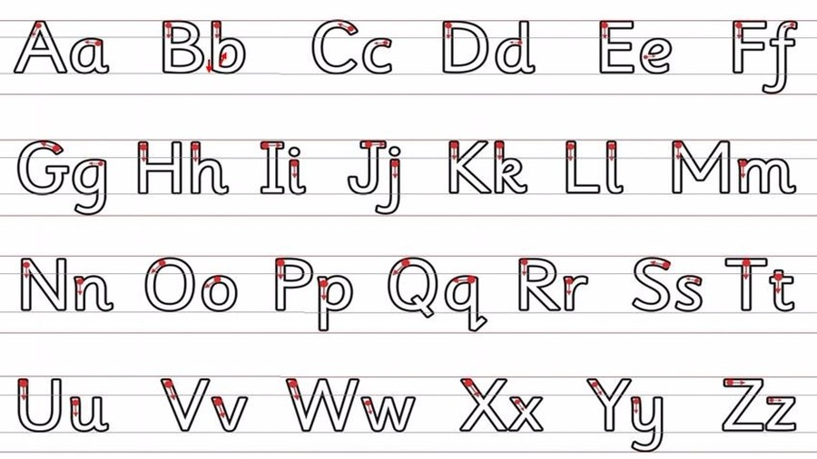
Maths
In Nursery and Reception, we follow the White Rose Maths scheme of learning.

Nursery-In Nursery, the children will begin to build with different shapes, say number names in order, and explore the concepts more than and fewer than.

Reception- In Reception, we will focus on numbers to 5, discuss patterns and learn about different 2D shapes.
British Values
This half term, the children will be learning about the following world events, including Harvest.
PE
Nursery- Nursery do not require a PE kit. However, they will have a taught PE session every Friday. The focus for this half term is dance.

Reception- Every Monday and Friday, the children will engage in a PE session. In Reception, the children should come to school dressed in their PE kit on these days. On Monday, Altrincham Football Club will teach fundamental movement skills. On Friday, the children will engage in a dance session.
Upcoming Events
Parent participation is encouraged for the following event:

Reading Workshops: Thursday 24th September 2026 | - Nursery- 4:00–5:00 PM  - Reception-5:00–6:00 PM
Maths Workshops: Tuesday 6th October 2026 | - Nursery- 4:00–5:00 PM  - Reception- 5:00–6:00 PM

How can you help my child at home?
- Read with your child at home
- Sing nursery rhymes
- Talk about numbers, colours, words and letters whilst you are out and about
- Cut and stick pictures from magazines
- Cook/bake together
- Plant seeds or bulbs
Reminders
A few reminders:
- Please ensure your child’s name is on all items of uniform.
- Please ensure your child has appropriate clothes for the weather – we play out every day!

Thank you for your continued support. As always, if you have any concerns, please do not hesitate to speak to us at the beginning or end of the day.

Mr Horan (EYFS Lead)



