
CLOVERLEA EYFS HANDBOOK

https://www.cloverlea.org.uk/
Green Lane North, Timperley, Altrincham, WA15 7NQ
0161 980 8338

Our Mission Statement: Inspiring children to care, learn and achieve

Welcome
This booklet is designed to give you information that will help you and your child familiarise yourselves with our Nursery and Reception classes. We hope you find the information useful. Our website also contains lots of information to support your child at school. However please do not hesitate to contact us if you require any further information or have any questions.

Working in Partnership
You are your child’s first teacher and have already played an important part in your child’s learning. We aim to develop a partnership with you, with knowledge, skills, and information flowing freely both ways. We therefore welcome and encourage your involvement in your child’s learning.

Our Staff Team
Name | Photograph | Job Role
Mr Horan |  | EYFS Teacher and Lead
Mrs Blackburn |  | Higher Level Teaching Assistant and Nursery Lead
Mrs Peers |  | Teaching Assistant
Mrs Denniston | 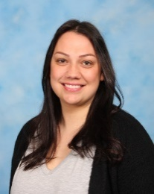 | Teaching Assistant
Mrs Harwood |  | Teaching Assistant

What is the Early Years Foundation Stage (EYFS)?
The EYFS is a distinct and important phase in education. It places an equal priority on supporting children’s social and emotional development, and their learning. The early years are the crucial time for developing children’s enjoyment of learning, their engagement and motivation. It’s an important time for children to develop their ability to persist and show determination.
This is the stage in your child’s life that gets them ready and prepares them for school, as well as for their future learning and successes. The EYFS was created to ensure your child’s first five years are happy, active, exciting, fun and secure, as well as to support their development, care and learning needs.
All nurseries, pre-schools, reception classes and childminders who are registered to deliver the EYFS must follow a legal document called the Statutory Framework for the Early Years Foundation Stage.

How your child will be learning?
Your child will be learning skills, acquiring knowledge and demonstrating their understanding through 7 areas of learning and development.
Children should mostly develop the 3 prime areas first:
- Communication and language
- Physical development
- Personal, social and emotional development
These prime areas are essential for your child’s healthy development and future learning.
As children grow, the prime areas will help them to develop skills in 4 specific areas:
- Literacy
- Mathematics
- Understanding the World
- Expressive Arts and Design

At Cloverlea, we believe in the holistic development of the learner through play. Our curriculum supports self-esteem, confidence, and communication, attitudes to learning and emotional development.

Our Topics
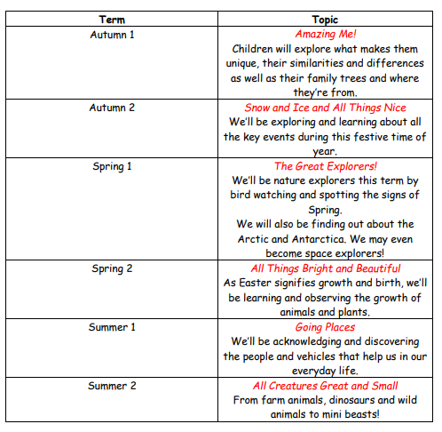
Assessment
Both EYFS staff and parents must work together, sharing information about the child, and what they have done at home and in school. When your child starts in our setting, observations will be made to ascertain where your child is at their stage of development. As your child journeys through EYFS with us we will record observations on Tapestry. You will be able to view and comment on these observations.
School times
Nursery
Morning | 8:40am – 11:45am
Afternoon | 1:15pm – 3:10pm
Full day | 8:40am – 3:10pm
Lunchtime | 11:45 am – 1:00pm

Reception
Start time | 8:40am
Lunchtime | 11:45 am – 1:00 pm
End time | 3:10pm

When you join us in September you will walk down the school path to bring your child directly to their class door. Here a member of staff will greet you and help your child with their belongings within the classroom to start the day.
At the end of your child’s school day please wait outside your child’s classroom, where you dropped them off in the morning. A member of staff will dismiss the children safely, one at a time, to their designated adult.

Snack
Every morning the children will receive a healthy snack from our free fruit scheme so there will be no need to send in separate snacks for break time. The children will also be allowed to have a drink of milk or water with their snack. If you would like your child to have milk, please complete the online form at www.coolmilk.com, there is a leaflet, with further information, in your pack.

Lunchtime
Nursery
Nursery children have the choice of a packed lunch or a hot dinner. Hot dinners can be provided at an additional cost of £2.90.

Reception
From 1st September 2014, free school meals became available for all pupils in Reception, Year 1 and Year 2. This widely announced government initiative is fully funded and covers all children of this age nationally. A separate letter will be sent home which will allow you to select whether you would like your child to have a free school meal or whether you would prefer to provide a packed lunch from home.

Water Bottles
All children are to bring a named water bottle into school each day, the Nursery and Reception children will use these bottles in the classroom. These water bottles can be purchased from the school office for £2.00. Children who have a packed lunch do not need to bring an additional drink at lunchtime as they can use these water bottles and we will refill them if they become empty.

School Uniform
Nursery
https://www.myembroiderysupplies.co.uk/product-category/uniform/cloverlea-primary/
Nursery children are required to wear the red school cardigan or jumper (found on the above link) with a white or red polo shirt that can be bought from most supermarkets or school clothing shops. They can wear grey or black trousers/joggers, skirts or leggings - whichever they feel most comfortable to move about in. Nursery will be taking part in PE lessons each week but do not need a PE kit. A red book bag can be purchased from the above website. These bags will be used to send home children’s learning, letters, water bottles etc. We request that footwear be sensible and appropriate for school activities.
Please name all garments- There is a lost property box and unclaimed/unnamed property will be disposed of at the end of each term.
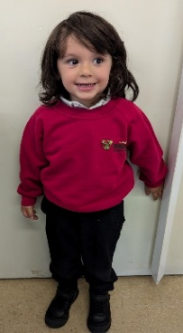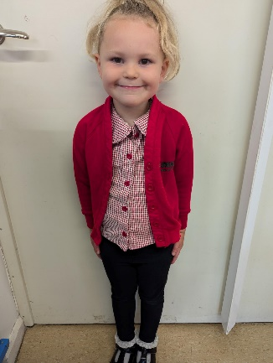
Nursery change of clothes bag
Nursery children are required to have a named pump bag with a spare change of clothes in case of any toileting accidents or mishaps.
Please include:
- 2 changes of underwear
- A pair of socks
- Spare trousers/leggings
- A t-shirt/top

These pump bags will be kept on your child’s cloakroom peg during term time and will be sent home each holiday.

Reception
https://www.myembroiderysupplies.co.uk/product-category/uniform/cloverlea-primary/
Reception children are required to wear the green school cardigan or jumper (found on the above link) with a white or red polo shirt that can be bought from most supermarkets or school clothing shops. They can wear grey trousers, shorts, skirts or a pinafore dress, whichever they feel most comfortable in.
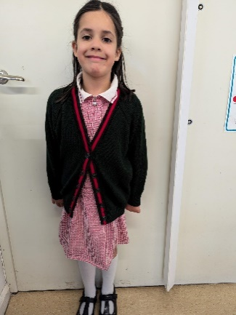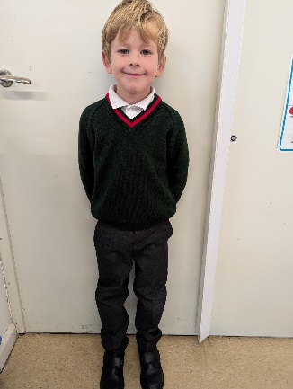
For P.E., the Reception children will require pumps or trainers, a red T-shirt with the school logo, and green school shorts (indoor kit). Please note the Reception children will need an outdoor kit (red logoed sweatshirt and black jogging bottoms. The children will come into school wearing their PE kit on their designated PE day. We request that footwear be sensible and appropriate for school activities.
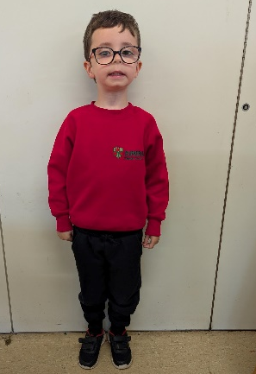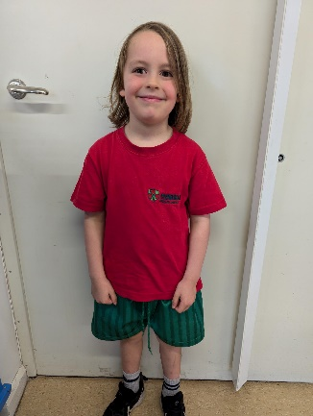
Any bags that are brought must be moderate in size as we do not have the space to store large rucksacks (book bags from the above website if possible). Please name all garments. There is a lost property box and unclaimed property will be disposed of at the end of each term.

Coats/suncream
Every day we go outside regardless of the weather. We ask parents to send their child in with a named coat they can put on independently. In the summer months, children will require a sun hat. Sun cream needs to be applied before school. In winter months, gloves and a hat will be needed but we request no scarves.

Cars in the School Drive / Arrangements at the School Gate
Walking is encouraged wherever possible. When dropping off and picking up children by car, parents are asked to park responsibly. Please park on one side only of Green Lane North and observe the no-parking zig-zag area. The staff car park is gated and only used by staff, visiting support staff, visiting medical staff who need quick and safe access in and out of the school. Parents are asked to work with Governors to minimise the risk to pupils at the main gate at the beginning and end of the school day. The school gate and pathway must be kept as clear as possible to ensure all pupils have a hazard-free exit from school. Please use the paved area inside the gate.

Early Years Fund
We ask all parents for a contribution of £1.00 per week to pay for snacks and enhance learning in the Foundation Stage. Bulk payment for a term would be greatly appreciated. All payments are to be made to a member of the EYFS team in cash.

Medical Information
School should be kept informed of any medical conditions that may affect a child’s performance in school. In general, children requiring asthma inhalers are encouraged to take responsibility for their treatment and must have their inhaler in school. The inhalers should be labelled and given to the class teacher. In the case of Nursery and Reception children, please speak to a member of staff.

Changes and Absences
Please keep the school informed of any changes in your child’s situation that would affect our internal records, i.e. name, address, and contact telephone numbers at home and at work so that we can keep our records up to date. We must have a daytime contact number in case of an emergency. Please put all changes in your child’s circumstances in a letter to the school office. If your child is going to be absent, please let us know on 0161 980 8338.

Finally
If you require any additional support and guidance about any worries or concerns affecting your child at home or in school, please contact Mr Horan (in confidence). Through experience, we have learnt that problems are best solved when parents and school work together.

